1. Student marks:

package com.torryharris.mainpath;
import java.util.Scanner;
public class Main
{
public static void main(String[] args)
{
Scanner sc = new Scanner(System.in);
System.out.println(“Enter the mark : ”);
int mark = sc.nextInt();
char opt;
if(mark>=90)
{
opt =’A’;
}
else if (80<=mark && mark<=89)
{
opt =’B’;
}
else if (70<=mark && mark<=79)
{
opt =’C’;
}
else if (60<=mark && mark<=69)
{
opt =’D’;
}
else if (50<=mark && mark<=59)
{
opt =’E’;
}
else
{
opt = ‘F’;
}
switch(opt)
{
case ‘A’ :
{
System.out.println(“Grade is : A”)
}
case ‘B’ :
{
System.out.println(“Grade is : B”)
}
case ‘C’ :
{
System.out.println(“Grade is : C”)
}
case ‘D’ :
{
System.out.println(“Grade is : D”)
}
case ‘E’ :
{
System.out.println(“Grade is : E”)
}
default:
{
System.out.println(“Grade is : F”)
}
}
}
}
Output 1:
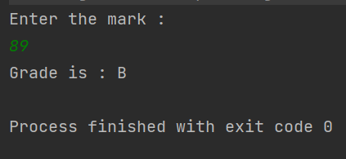

Output 2:

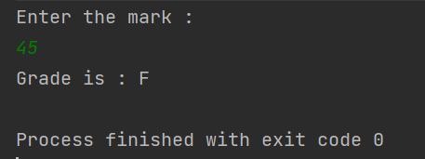

2. PASCAL’S TRIANGLE :

Main.java
package com.torryharris;

public class Main
{
public static void main(String[] args)
{
int n=4, I, j;
Pascal p = new Pascal();
for(int i=0;i<=n;i++)
{
for(j=0;j<=n;j++)
{
System.out.println(“ ”);
}
for(j=0;j<=i;j++)
{
System.out.print(“ ”+p.factorial(i)/(p.factorial(i-j) * p.factorial(j)));
}
System.out.println();
}

}
}

Pascal.java

package com.torryharris;
public class Pascal
{
public int factorial(int I)
{
if(i==0)
{
return 1;
}
return i*factorial(i-1);
}
}

Output :

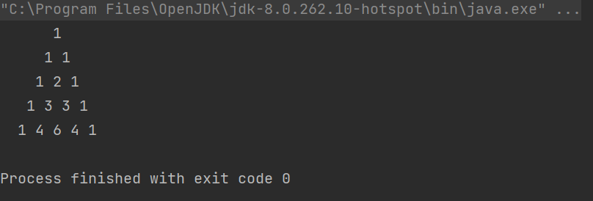

3. MAGIC NUMBER :

package com.torryharris.mainpath;
import java.util.Scanner;
public class Main
{
public static void main (String[] args)
{
int n;
Scanner sc = new Scanner(System.in);
System.out.println(“Enter the number : ”);
n= sc.nextInt();

if(isMagic(n));
{
System.out.println(n+“ is a Magic Number.”);
}
else
{
System.out.println(n+” is not a Magic Number.”);
}
}

public static boolean isMagic(int n)
{
int sum = 0;
while (n > 0 || sum > 9)
{
if(n==0)
{
n = sum;
sum = 0;
}
sum += n%10;
n/=10;
}
return (sum == 1);
}
}

Output 1 :

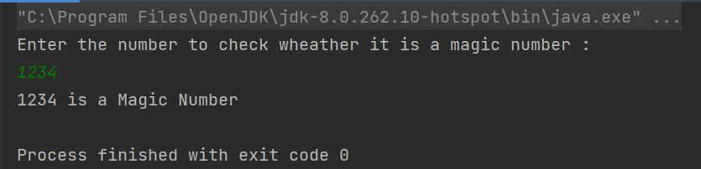

Output 2 :

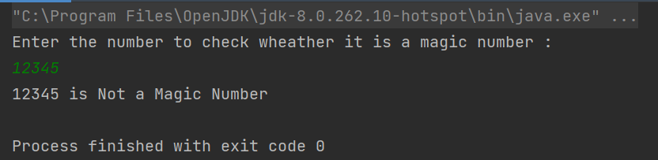

4. GCD and LCM :

package com.torryharris;

import java.util.Scanner;

public class Main
{
public static void main (String[] args)
{
int temp1, temp2, num1, num2, temp, hcf, lcm;

Scanner sc = new Scanner(System.in);
System.out.println(“Enter first number : ”);
num1 = sc.nextInt();
System.out.println(“Enter second number : ”);
num2 = sc.nextInt();
sc.close();

temp1 =num1;
temp2 =num2;
while(temp2 != 0)
{
temp = temp2;
temp2 = temp1 % temp2;
temp1 = temp;
}

hcf = temp1;
lcm = (num1*num2)/hcf;

System.out.println(“HCF of input numbers: ”+hcf);
System.out.println(“LCM of input numberes: ”+lcm);

}
}

Output :

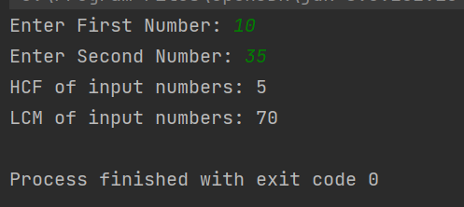

5. PALINDROME :

1.Palindrome number:- If the Reverse of a number is equal to the same number then the
number is called palindrome number.

Palindrome
package com.thbs;

public class Main {

public static void main(String[] args) {
int r,sum=0,temp;
int n=454;//It is the number variable to be checked for palindrome

temp=n;
while(n>0){
r=n%10; //we get remainder
sum=(sum*10)+r;
n=n/10;
}
if(temp==sum)
System.out.println("palindrome number ");
else
System.out.println("not palindrome");
}
}

Output:
palindrome number

2.Java program to find the sum of even and odd digits in a given number.
Sum of even and odd
package com.thbs;

public class Main {

public static void main(String[] args) {
int n = 457892;
getSum(n);
}

static int reverse(int n)
{
int rev = 0;
while (n != 0) {
rev = (rev * 10) + (n % 10);
n /= 10;
}
return rev;
}

static void getSum(int n)
{
n = reverse(n);
int sumOdd = 0,sumEven = 0, c = 1;

while (n != 0) {
if (c % 2 == 0)
sumEven += n % 10;
else
sumOdd += n % 10;
n /= 10;
c++;
}

System.out.println("Sum odd = " + sumOdd);
System.out.println("Sum even = " + sumEven);
}
}

Output:
Sum odd = 20
Sum even = 15

3.A number whose sum of its digits powered with their respective position is
equal to the original number is called disarium number.
Examples of disarium numbers are- 135, 175, 518 and e.tc.
Number = 89 => 81 + 92 = 8 + 81 = 89 So, 89 is a disarium number.
Number = 135 => 11 + 32 + 53 = 1 + 9 + 125 = 135 Hence 135 is a disarium number.
Number = 518 => 51 + 12 + 83 = 5 + 1+ 512 = 518 So, 518 is a disarium number.

DisariumNumber
package com.thbs;

public class Main {

public static void main(String[] args) {
int num = 175, sum = 0, rem = 0, n;//1^1+7^2+5^3=175
int len = calculateLength(num);

n = num;

while(num > 0){
rem = num%10;
sum = sum + (int)Math.pow(rem,len);
num = num/10;
len--;
}

//Checks whether the sum is equal to the number itself
if(sum == n)
System.out.println(n + " is a disarium number");
else
System.out.println(n + " is not a disarium number");
}
public static int calculateLength(int n){
int length = 0;
while(n != 0){
length = length + 1;
n = n/10;
}
return length;
}
}

Output:
175 is a disarium number

4.What is a Krishnamurthy Number?
If the sum of the factorial of all digits of a number is equal to the
original number then the number is called Krishnamurthy Number.
For example- 145 and 40585 are Krishnamurthy numbers. 1 and 2 are also
Krishnamurthy numbers because their factorials are equal to the same number.
145
=> 1! + 4! + 5!
=> 1 + 24 + 120
=> 145
The sum of the factorial of individual digits is the same as the original number 145.
Hence, 145 is .a Krishnamurthy number.
Krishnamurthy Number
package com.thbs;

public class Main {

public static void main(String[] args) {
int n = 145;//1!+4!+5!=1+24+120=145
if (isKrishnamurthy(n))
System.out.println("YES");
else
System.out.println("NO");
}
static int factorial(int n)
{
int fact = 1;
while (n != 0) {
fact = fact * n;
n--;
}
return fact;
}

// function to Check if number is krishnamurthy
static boolean isKrishnamurthy(int n)
{
int sum = 0;

int temp = n;
while (temp != 0) {

sum += factorial(temp % 10);

temp = temp / 10;
}
return (sum == n);
}
}

Output:
YES
9.
FIBONACCI

package com.thbs;
import java.util.*;
public class Main {

public static void main(String[] args) {
// write your code here
Scanner s =new Scanner (System.in);
int fib1=0,fib2=1,fib3,n,count=0;
System.out.println("Enter n");
n= s.nextInt();
System.out.println(fib1+"\n"+fib2);
count=2;
while(count<n)
{
fib3=fib1+fib2;
count++;
System.out.println(fib3);
fib1=fib2;
fib2=fib3;
}
}
}

OUTPUT

Enter n :10

0
1
1
2
3
5
8
13
21
34

10.CONVERSION FROM CELSIUS TO FAHRENHEIT

package com.thbs;
import java.util.*;
public class Main {

public static void main(String[] args) {
// write your code here
Scanner s=new Scanner(System.in);
System.out.println("enter the value in Celsius");
float c=s.nextFloat();
float F;
F=(c*9/5)+32;
System.out.println("Value in Fahrenheit is "+F);
}
}

OUTPUT

enter the value in Celsius
96
Value in Fahrenheit is 204.8

11.TO FIND LARGEST NUM IN ARRAY

package com.thbs;
import java.util.*;
public class Main {

public static void main(String[] args) {
// write your code here
Scanner s=new Scanner(System.in);
int n;
System.out.println("enter n");
n=s.nextInt();
int[] a = new int[n];
System.out.println("Enter the elements");
for(int i=0;i<n;i++)
{
a[i]=s.nextInt();
}
int max=a[0];
for(int i=1;i<n;i++)
{
if(a[i]>max)
max=a[i];
}
System.out.println("max num in array is"+max);

}
}

OUTPUT

enter n
5
Enter the elements
76
98
87
54
34
max num in array is 98

12.TO MERGE 2 SORTED ARRAY

package com.thbs;
import java.util.*;
public class Main {

public static void main(String[] args) {
// write your code here
Scanner s=new Scanner(System.in);

System.out.println("enter n of array 1");
int n=s.nextInt();
int[] a = new int[n];
System.out.println("Enter 2 sorted array");
System.out.println("Enter the elements of array 1 in sorted order");
for(int i=0;i<n;i++)
{
a[i]=s.nextInt();
}

System.out.println("enter n of array 2");
int m=s.nextInt();
int[] b = new int[m];
System.out.println("Enter the elements of array 2 in sorted order");
for(int i=0;i<m;i++)
{
b[i]=s.nextInt();
}
int i=0,j=0,k=0;

int[] c = new int[m+n];
while(i<m && j<n )
{
if(a[i]<b[j])
c[k++]=a[i++];
else
c[k++]=b[j++];
}
System.out.println("Elements in sorted order");
for(i=0;i<(m+n);i++)
{
System.out.println(c[i]);
}
}
}

OUTPUT
enter n of array 1
4
Enter 2 sorted array
Enter the elements of array 1 in sorted order
2
4
6
8
enter n of array 2
4
Enter the elements of array 2 in sorted order
3
5
7
9
Elements in sorted order 2 3 4 5 6 7 8 9

13)
package com.torryharris;
public class Main {
public static void main(String[] args) {
// write your code here
int arr[]={50,20,10,40,20,20,10,10,60,30,70};
int temp[]=new int[arr.length];
int count = 0;
for(int i=0;i<arr.length;i++){
int element = arr[i];
boolean flag = false;
for(int j=0;j<count;j++){
if(temp[j]==element){
flag = true;
break;
}
}
if(flag){
continue;
}
for(int j=i+1;j<arr.length;j++){
if(arr[j] == element){
temp[count++]=element;
break;
}
}
}
System.out.println("total repeted elements: "+count);
System.out.println("repeted elements are: ");
for(int i=0;i<count;i++){
System.out.println(temp[i]+" ");
}
}
}
Output:
total repeted elements: 2
repeted elements are:
20
10

14)
package com.torryharris;
import java.util.Arrays;
public class Main {
public static void main(String[] args) {
// write your code here
int arr[] = {30, 50, 20, 50, 10, 20, 30, 10, 10, 40};
int newArr[] = removeDuplicates(arr);
System.out.println("Original array: " + Arrays.toString(arr));
System.out.println("After removing duplicates: " + Arrays.toString(newArr));
}
public static int[] removeDuplicates(int[] arr) {
int index = 1;
for (int i = 1; i < arr.length; i++) {
int element = arr[i];
for(int j=0; j<index; j++) {
if(arr[j] == element) {
break;
}
if(j == index-1) {
arr[index++] = element;
break;
}
}
}
return Arrays.copyOf(arr, index);
}
}
Output:
Original array: [30, 50, 20, 10, 40, 20, 30, 10, 10, 40]
After removing duplicates: [30, 50, 20, 10, 40]

15)
package com.torryharris;
import java.util.Arrays;
public class Main {
public static int[] addElement(int[] arr, int element) {
int temp[] = new int[arr.length+1];
for (int i = 0; i < arr.length; i++) {
temp[i] = arr[i];
}
temp[arr.length] = element;
return temp;
}
public static void main(String[] args) {
int arr[] = { 30, 50, 20, 40, 10};
int element = 99;
System.out.println("Original array: " + Arrays.toString(arr));
arr = addElement(arr, element);
System.out.println("New array: " + Arrays.toString(arr));
}
}

Output:
Original array: [30, 50, 20, 40, 10]
New array: [30, 50, 20, 40, 10, 99]

16)
package com.torryharris;
import java.util.Scanner;
import java.lang.Math;
public class Main {
static boolean isArmstrong(int n)
{
int temp, digits=0, last=0, sum=0;
temp=n;
while(temp>0)
{
temp = temp/10;
digits++;
}
temp = n;
while(temp>0)
{
last = temp % 10;
sum += (Math.pow(last, digits));
temp = temp/10;
}
if(n==sum)
return true;
else return false;
}
public static void main(String args[])
{
int num;
Scanner sc= new Scanner(System.in);
System.out.print("Enter the limit: ");
num=sc.nextInt();
System.out.println("Armstrong Number up to "+ num + " are: ");
for(int i=0; i<=num; i++)
if(isArmstrong(i))
System.out.print(i+ ", ");
}
}
Output:
Enter the limit: 1000
Armstrong Number up to 1000 are:
0, 1, 2, 3, 4, 5, 6, 7, 8, 9, 153, 370, 371, 407,

assesment
(17)
package com.torryharris.mainpack;

import java.util.Scanner;

public class Main {

public static void main(String[] args) {
Scanner sc=new Scanner(System.in);
System.out.println("Enter the number");
int n=sc.nextInt();

if(isAutomorphic(n)){
System.out.println(n+" is automorphic");
}else
System.out.println(n+" is not automorphic");
}
static boolean isAutomorphic(int num)
{
int square = num * num;
while (num > 0)
{
if (num % 10 != square % 10)
return false;

num = num/10;
square = square/10;
}
return true;
}
}

19
package com.torryharris.mainpack;
import java.util.Scanner;
public class Main {

public static void main(String[] args) {
System.out.print("Please enter your weight in kg: ");
Scanner s = new Scanner(System.in);
float weight = s.nextFloat();
System.out.print("Please enter your height in m: ");
float height = s.nextFloat();
calculateBMI(weight,height);
}

private static void calculateBMI(float weight,float height) {
float bmi = (weight)/(height*height);
System.out.println("Your BMI is: "+bmi);
printBMICategory(bmi);

}
private static void printBMICategory(float bmi) {
if(bmi < 18.5) {
System.out.println("You are thinness");
}else if (bmi < 25) {
System.out.println("You are normal");
}else if (bmi < 30) {
System.out.println("You are overweight");
}else {
System.out.println("You are obese");
}
}
}
19
package com.torryharris.mainpack;

import java.util.Scanner;

public class Main {
public static void main(String args[])
{
long n, sum=0;
Scanner sc=new Scanner(System.in);
System.out.print("Enter the number: ");
n=sc.nextLong();
int i=1;

while(i <= n/2)
{
if(n % i == 0)
{
sum = sum + i;
}
i++;
}
if(sum==n)
{
System.out.println(n+" is a perfect number.");
}
else
System.out.println(n+" is not a perfect number.");
}
}
(20)
package com.torryharris.mainpack;

import java.util.Scanner;

public class Main {

public static void main(String[] args) {
Scanner sc=new Scanner(System.in);
System.out.println("Enter the array size");
int n=sc.nextInt();
int ar[]=new int[n];
System.out.println("Enter the "+n+"array elements");
for(int i=0;i<n;i++)
ar[i]=sc.nextInt();
System.out.println("Second largest num: "+getSecondLargest(ar,n));
}
public static int getSecondLargest(int[] a, int total){
int temp;
for (int i = 0; i < total; i++)
{
for (int j = i + 1; j < total; j++)
{
if (a[i] > a[j])
{
temp = a[i];
a[i] = a[j];
a[j] = temp;
}
}
}
return a[total-2];
}
}

